**Simple Makefile creation with 1 directory**

**Ref : Exercise 1 zip file in training link**

**Exercise 1 zip file contains source structure for which makefile needs to be created.**

**- Makefile needs to be implemented for following source structure**

**1) 2 source files**

**2) 1 user generated custom library**

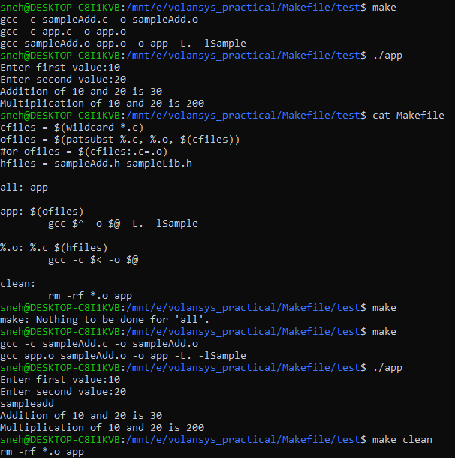

**- Makefile should control 1 MACRO definition (Enable / Disable "DECORATE" macro and see the diff in results)**

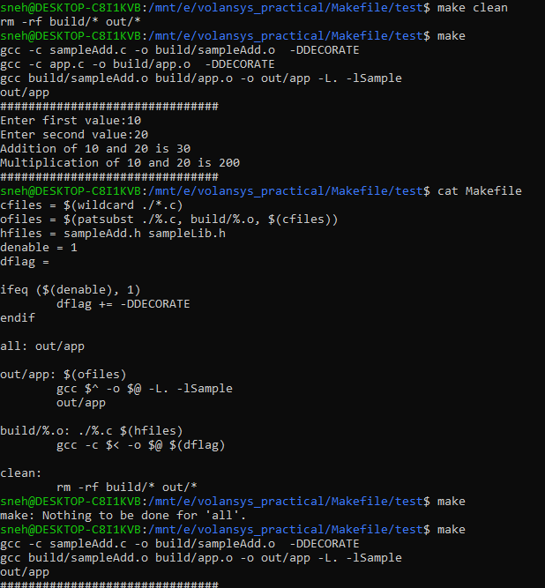

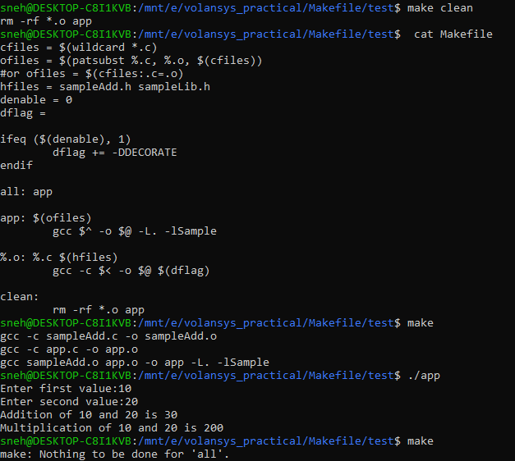

**- Makefile should generate output Executable in "out" directory and object files in "build" directory. Makefile should have clean function to delete build output and temporary files**



**Modify Makefile to use library and header file from external directories**

**Ref: Exercise 3 zip file in training link**

**Use makefile for Exercise 1 as ref and change to run for Exercise 3 zip file sample code**

